20___-__________-___
(date)

Warranty claim

Product information:
1) Product name: PTL-16F
2) Serial nr. and (or) VIN: PTL20F2PPM93DT101
3) Production number: 3200
4) Production year: 2017
A copy of the invoice

User Information:
Name, surname / Company name:
RICK SANCHEZ
Address:
Technikos g. 5, Keleriškių km., 57342, Kėdainiai

Contact phone number: +37034742390
Email address:
client@mail.com

Description of the problem (detail the fault, time of its occurrence, circumstances, provide visual material):

Oil dripping from the trailer side hydraulic cylinder

When filling in the form, all fields must be filled in. A scanned copy of the original invoice must be provided.
The warranty is valid only for defect that occurred during the manufacture of the product; the warranty does not cover problems caused by natural wear, users negligence, overloading, using implement without compliance to the operating instructions, misuse, repair without consulting the manufacturer. Working parts, tires, brakes, bearings etc. are considered part of natural wear and the warranty does not apply, cf. manual. Machinery must be emptied and cleaned before providing it to warranty repairs.
By sending this warranty claim, I agree to the transfer of this personal data to UAB "Laumetris"
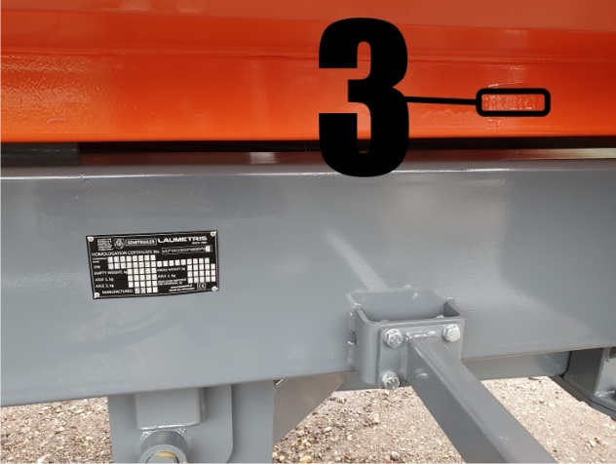
_________________________________________
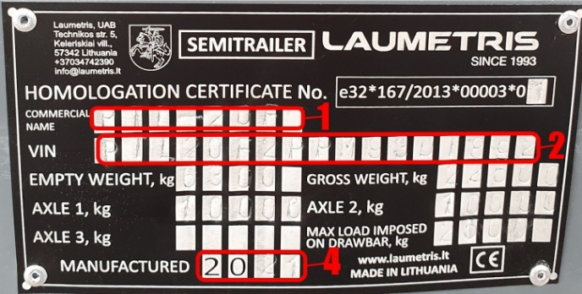
Users Name, Surname, Signature, Date

